Nama : Viona Paramitha

Kelas : 5C

NIM : 18090097

Praktikum 2

1. Source Code : latihan1.php >>> application/controllers

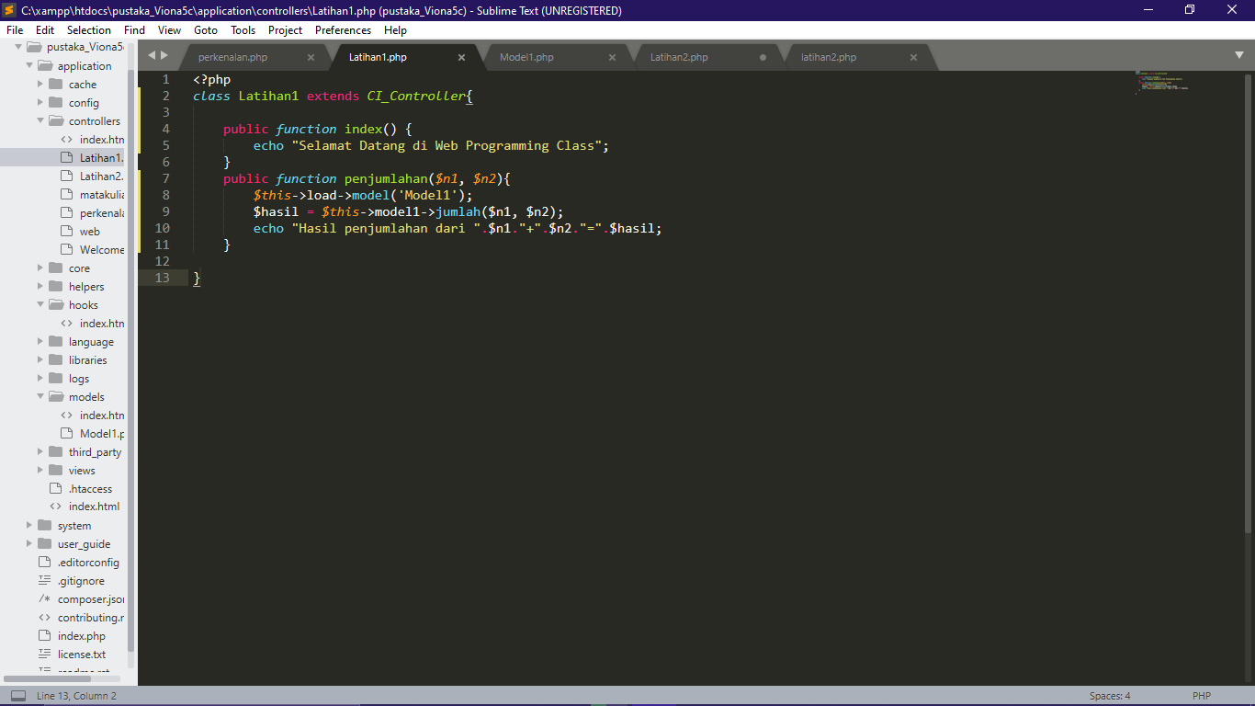

Source Code : latihan2.php >>> application/controllers

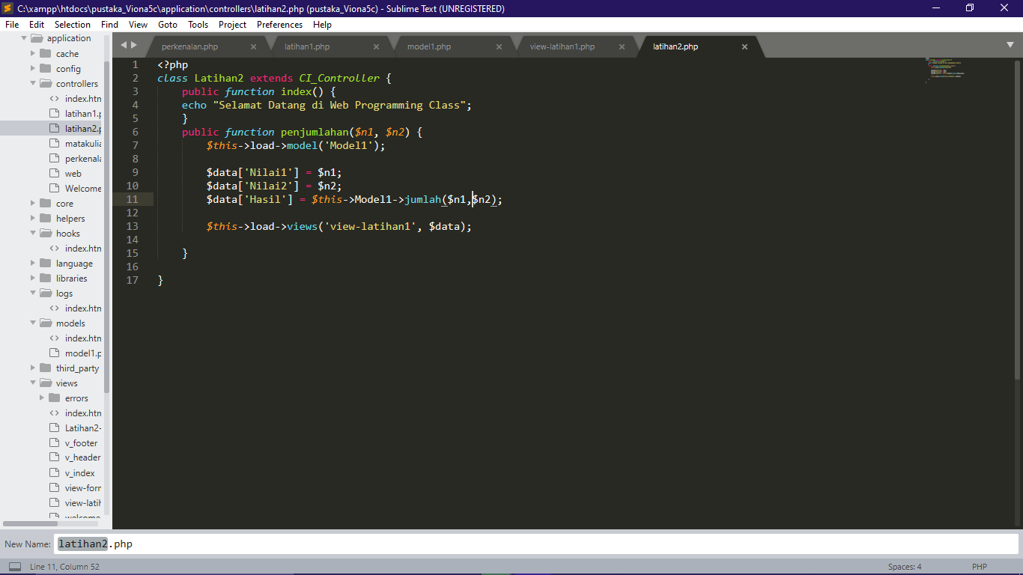

Source Code : view-latihan1.php >>> application/views

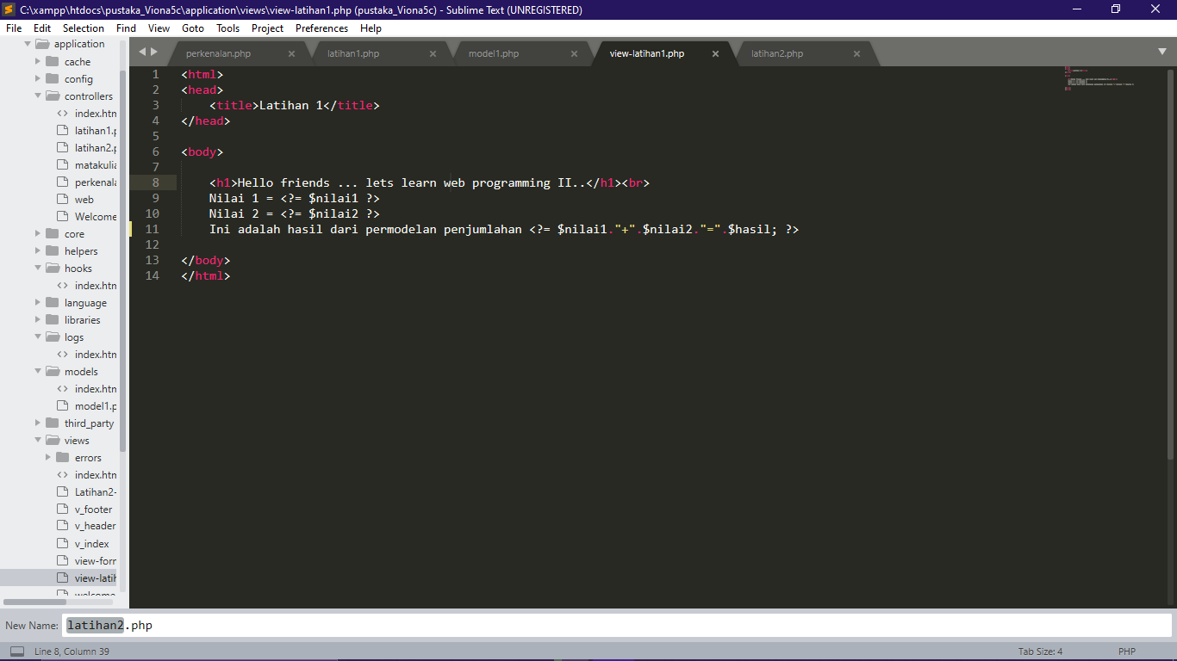

Source Code : model1.php >>> application/models

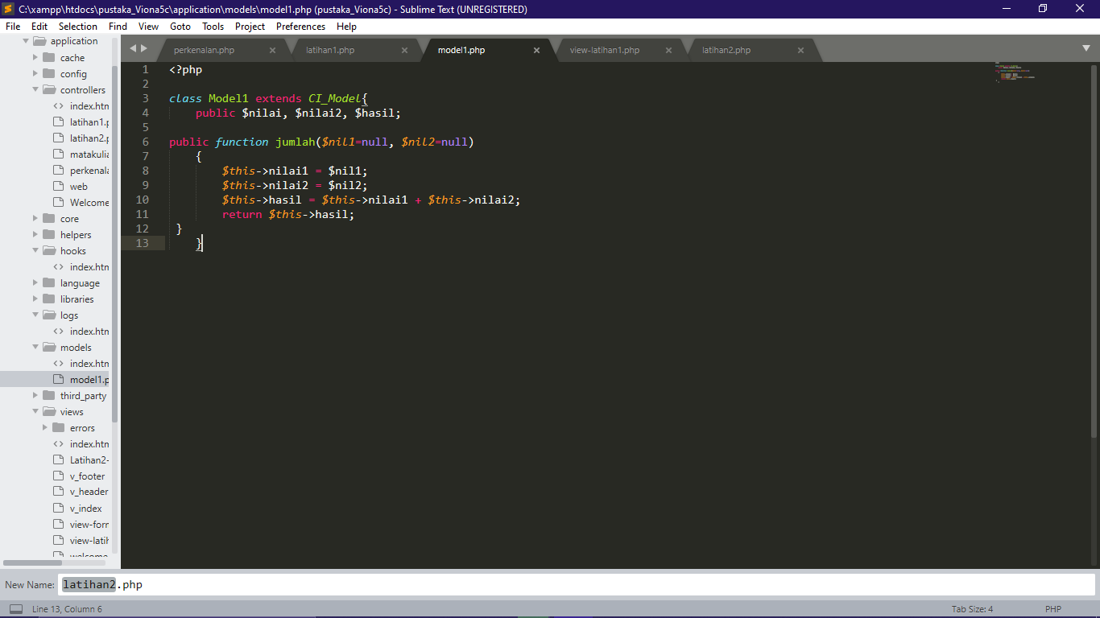

1. Hasil dari praktikum

<http://localhost/pustaka_Viona5c/index.php/latihan1>

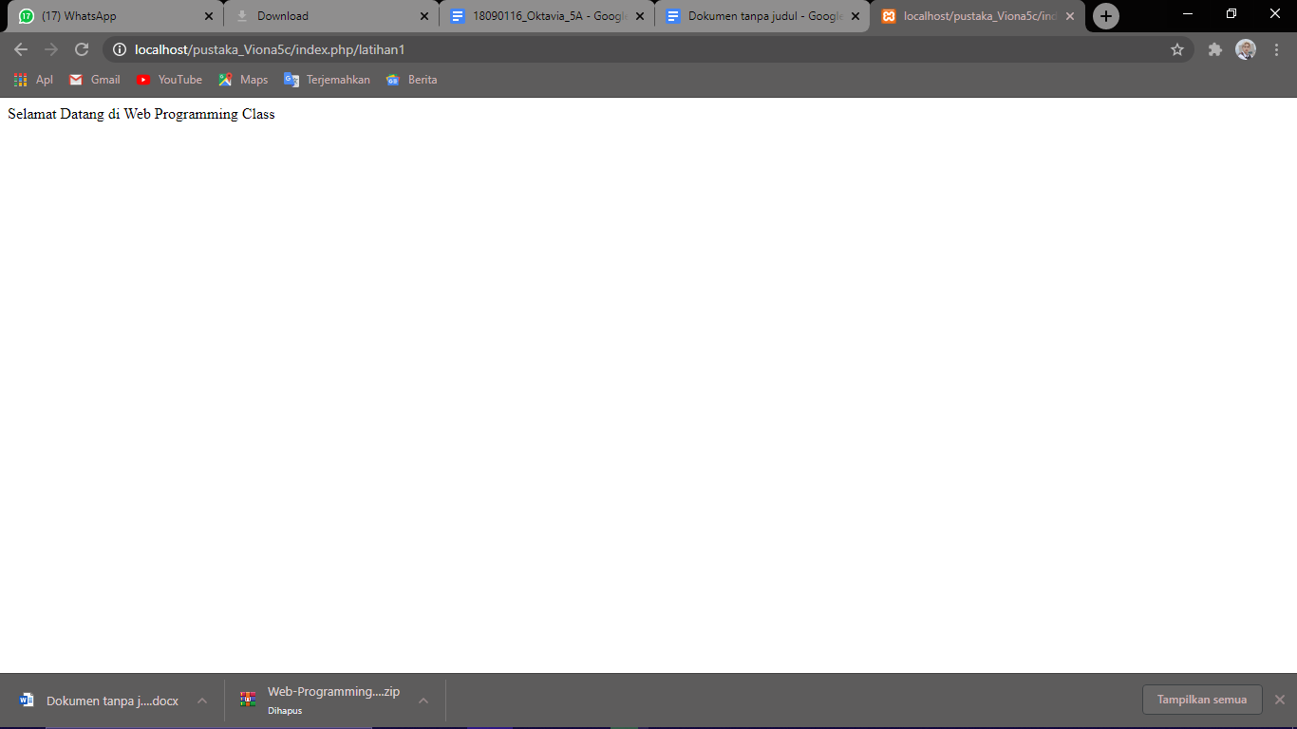

<http://localhost/pustaka_Viona5c/index.php/latihan1/penjumlahan/3/5>

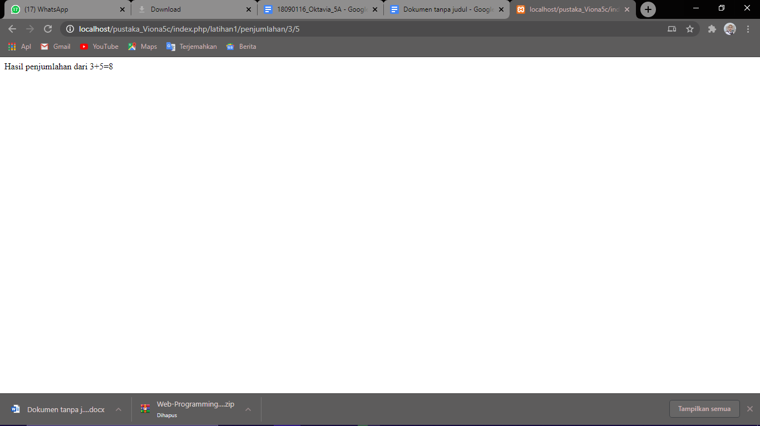

<http://localhost/pustaka_Viona5c/index.php/latihan2/penjumlahan/5/6>

